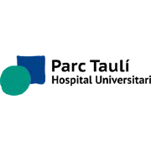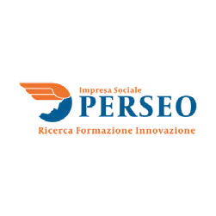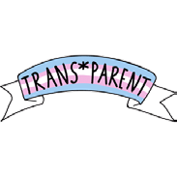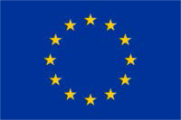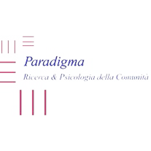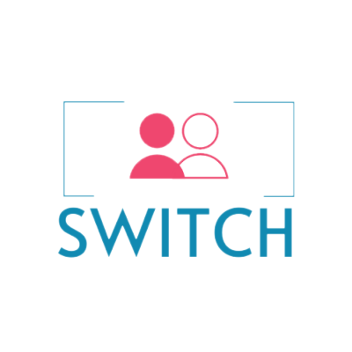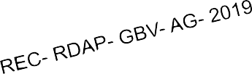

# **DELIVERA BLE 2. 4**

MEMORANDUM OF UNDERSTANDING

This project was funded by the European Union’s Rights, Equality and Citizenship Programme (2014-2020).

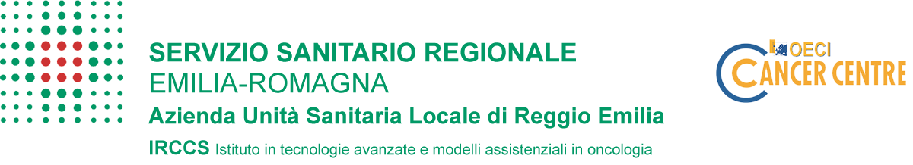

The content of this deliverable represents the views of the authors only and is their sole responsibility. The European Commission does not accept any responsibility for use that may be made of the information it contains.

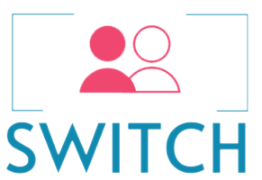



**SWITCH team:**

Aragón A. M.; Baione, M.; Bonvicini, F.; Brando-Garrido, C.; Campanino, M.; Cardoner N.; Casoni, C.; Catilino, F.; Dolezalova, P.; Escotorin-Soza, P.; Espelt C.; Giuliani, S.; Goldberg, X.; Graglia, M.; Heumann, V.; Malkova, M.; Marino, M.; Moscano, E.; Orlikova, B.; Pavlica, K.; Riboldi, B.; Roche, O. R.; Roche, V. I.; Salzillo, S.; Sanzo I.; Simonova, Z.; Tedesco, I.

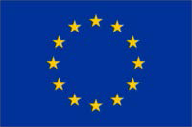This project was funded by the European Union’s Rights, Equality and Citizenship Programme (2014-2020).



The content of this deliverable represents the views of the authors only and is their sole responsibility. The European Commission does not accept any responsibility for use that may be made of the information it contains.

SWITCH PROJECT 2020

# Introduction

# Memorandum of public-private Understanding between Health Care Services & Transgender Association to activate therapeutic and specialist consultancy paths is a SWITCH Project’s tool.

# It contains declarations of intent that local public health bodies in the partner Countries can sign with private assistance centers and transgender associations to activate therapeutic and specialist consultancy paths.

# The objective is the start-up of a networking activity among public health care bodies and transgender and intersex survivors (TI), private centers and associations including Recommendations to health care regional authorities in all Countries to support TI’s health equity.

**MEMORANDUM OF PUBLIC-PRIVATE UNDERSTANDING**

between

Health Care Services & Transgender Association to activate therapeutic and specialist consultancy paths

This Memorandum of Understanding is between the following parties:

**On the one part,**

the (Public Institute) ____________________________, established in (address) _____________________, VAT number __________________, represented by ___________________, born in _____________ in date ___________________.

**and on the other part,**

the (Private Institute) ____________________________, established in (address) _____________________, VAT number __________________, represented by ___________________, born in _____________ in date __________________.

The parties referred to above have agreed to enter into the agreement under the terms and conditions below.

BACKGROUND AND MISSION

This Memorandum of Understanding is a significant part of SWITCH Project (Supporting Wellbeing and Integration of Transgender victims in Care environments with Holistic approach). SWITCH is a project funded by the European Commission under the program "Rights, equality, citizenship" (REC-RDAP-GBV-AG-2019) which sees the involvement 7 partners from three European Union countries: Italy (Perseo SpA Impresa sociale, Paradigma, Research and Psychology of the Onlus community and Local Health Unit of Reggio Emilia), Czech Republic (Transparent Zs and Narodni Ustav Dusevniho Zdravi) and Spain (Fundazio Parc Tauli and Mirada Local Sl). The general objective is to promote compassionate services to assist properly transgender and intersex survivors (TI) by enhancing competencies of psychiatrists, psychologists, psychotherapist and other social workers (direct target).

TI people high exposition to discrimination and harassment exacerbate their risk for mental disorders, addictions and suicide (APA, 2015). Despite the need for healthcare assistance, the relationship with public services remains problematic, also due to the staffs’ implicit prejudices, and poor preparation (Carroll et al, 2012).

PURPOSE OF THIS MEMORANDUMOF UNDERSTANDING

This Memorandum of Understanding (“MOU”) is made and entered into among public and private entities providing for TI supports, self-help groups promotion and information supports for both professionals and TI and their relatives.

This MOU is to serve as the operating agreement between the parties for the purpose of providing and coordinating preventative and healthcare services to transgender and intersex survivors (TI).

The parties agree that this MOU is intended to ensure the parties’ agreement and common understanding of regulatory guidance and policies, so as to support coordination and integration efforts and health and education professionals.

INTENDED RESULTS

Public and private entities share a commitment to building a health services delivery system that increases access to comprehensive health services through collaboration and formal partnership. Intended outcomes of system delivery include the following:

1. More efficient use of resources;
2. Stronger linkages to local and community partners.

GENERAL TERMS, CONDITION AND RESPONSIBILITIES OF THE PARTIES

The purpose of this MOU is to formalize terms and conditions under which the parties shall work together. Each party shall defend, indemnify and hold harmless the other for its negligent acts or omission and those of its officers, employees, agents, or students, howsoever caused.

Roles of Public Institute: ___________________________________________________

Roles of Private Institute: __________________________________________________

EXECUTION OF MEMORANDUM OF UNDERSTANDING

The parties agree that:

1. This MOU is expressly subject to and shall not become effective or binding on any party hereto until it has been fully executed by all parties.
2. The MOU shall be binding on all parties, their successors and assigns.
3. The MOU reflects the entire MOU between the parties with respect to the subject matter hereof and supersedes all other prior oral or written statements, understandings or correspondence.
4. The persons signing and executing the MOU have been fully authorized to execute this agreement and to validly and legally bind to all the terms, performances and provisions herein set forth.

**IN WITNESS WHEREOF,** the duly authorized representatives of the Parties have executed this MOU effective as of the date first above written.

Dated: ________ by___________________________ (legal representative)

Dated: ________ by ___________________________ (legal representative)